**ÇİFTLİK (DOĞU) BAĞLANTI ROTASI**

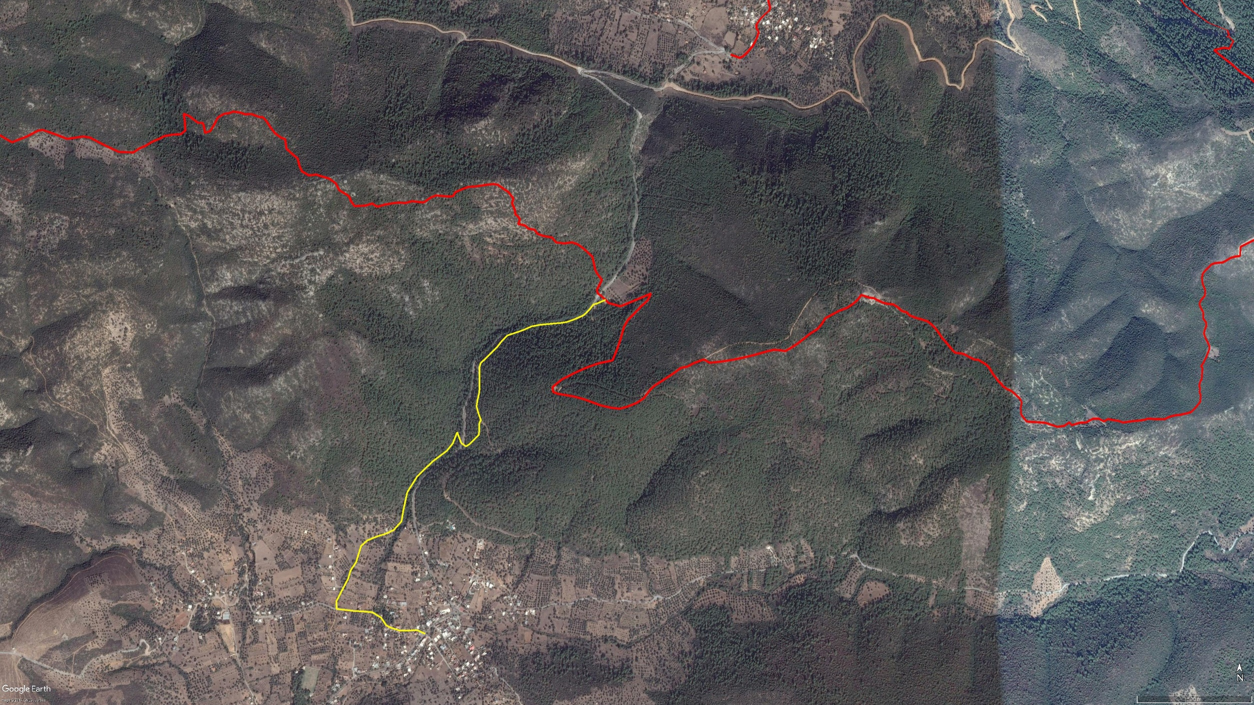

**Gedikgöl**

**Kaplan Dağı**

**Theangela**

**BOY KESİT**

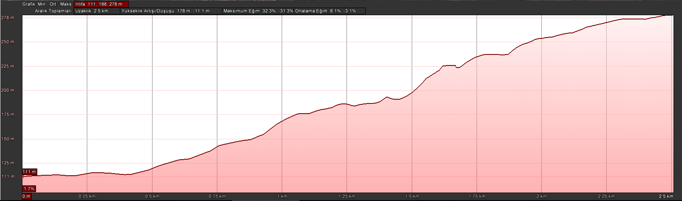

**Çiftlik (Doğu)**

**Gedikgöl**

**KOORDİNATLAR**

|  |  |  |
| --- | --- | --- |
| S.NU. | ENLEM | BOYLAM |
| 1 | 37.031263407 | 27.573626176 |
| 2 | 37.031402088 | 27.573228022 |
| 3 | 37.031387141 | 27.572798866 |
| 4 | 37.031380901 | 27.572413788 |
| 5 | 37.031501285 | 27.571927518 |
| 6 | 37.031588468 | 27.571724442 |
| 7 | 37.031892008 | 27.571461617 |
| 8 | 37.032099248 | 27.571036935 |
| 9 | 37.032130350 | 27.570571257 |
| 10 | 37.032150447 | 27.570106646 |
| 11 | 37.032225319 | 27.569296486 |
| 12 | 37.032532473 | 27.569288244 |
| 13 | 37.033082567 | 27.569643067 |
| 14 | 37.033406491 | 27.569853833 |
| 15 | 37.033725505 | 27.569975130 |
| 16 | 37.034060046 | 27.570247367 |
| 17 | 37.034684279 | 27.570486144 |
| 18 | 37.034899345 | 27.570789731 |
| 19 | 37.035052920 | 27.571253351 |
| 20 | 37.035153192 | 27.571665415 |
| 21 | 37.035307166 | 27.572076608 |
| 22 | 37.035647063 | 27.572456250 |
| 23 | 37.036120630 | 27.572554789 |
| 24 | 37.036783359 | 27.572737539 |
| 25 | 37.037400637 | 27.573221689 |
| 26 | 37.037980120 | 27.573962999 |
| 27 | 37.038401557 | 27.574665240 |
| 28 | 37.038682509 | 27.574951164 |
| 29 | 37.039119628 | 27.575169398 |
| 30 | 37.038705371 | 27.575363395 |
| 31 | 37.038574331 | 27.575597013 |
| 32 | 37.038662858 | 27.575778874 |
| 33 | 37.039036462 | 27.576231627 |
| 34 | 37.039482385 | 27.576250994 |
| 35 | 37.039596998 | 27.576322423 |
| 36 | 37.039873260 | 27.576200188 |
| 37 | 37.040135675 | 27.576112432 |
| 38 | 37.040343065 | 27.576150146 |
| 39 | 37.040664019 | 27.576238982 |
| 40 | 37.040897453 | 27.576258805 |
| 41 | 37.041320560 | 27.576260778 |
| 42 | 37.041664754 | 27.576254675 |
| 43 | 37.041816291 | 27.576307965 |
| 44 | 37.042026128 | 27.576578639 |
| 45 | 37.042223803 | 27.576826924 |
| 46 | 37.042463077 | 27.577126192 |
| 47 | 37.042678141 | 27.577333124 |
| 48 | 37.042901710 | 27.577614680 |
| 49 | 37.042977006 | 27.577906300 |
| 50 | 37.043114852 | 27.578395462 |
| 51 | 37.043257275 | 27.578797213 |
| 52 | 37.043312298 | 27.579170713 |
| 53 | 37.043366354 | 27.579850855 |
| 54 | 37.043389316 | 27.580200310 |
| 55 | 37.043424315 | 27.580484802 |
| 56 | 37.043491824 | 27.580747138 |
| 57 | 37.043591398 | 27.581056021 |
| 58 | 37.043699286 | 27.581344726 |
| 59 | 37.043911989 | 27.581609662 |
| 60 | 37.044111741 | 27.581811100 |
| 61 | 37.044152234 | 27.581988485 |
| 62 | 37.044297308 | 27.582405302 |