**KARABAĞ BAĞLANTI ROTASI**

****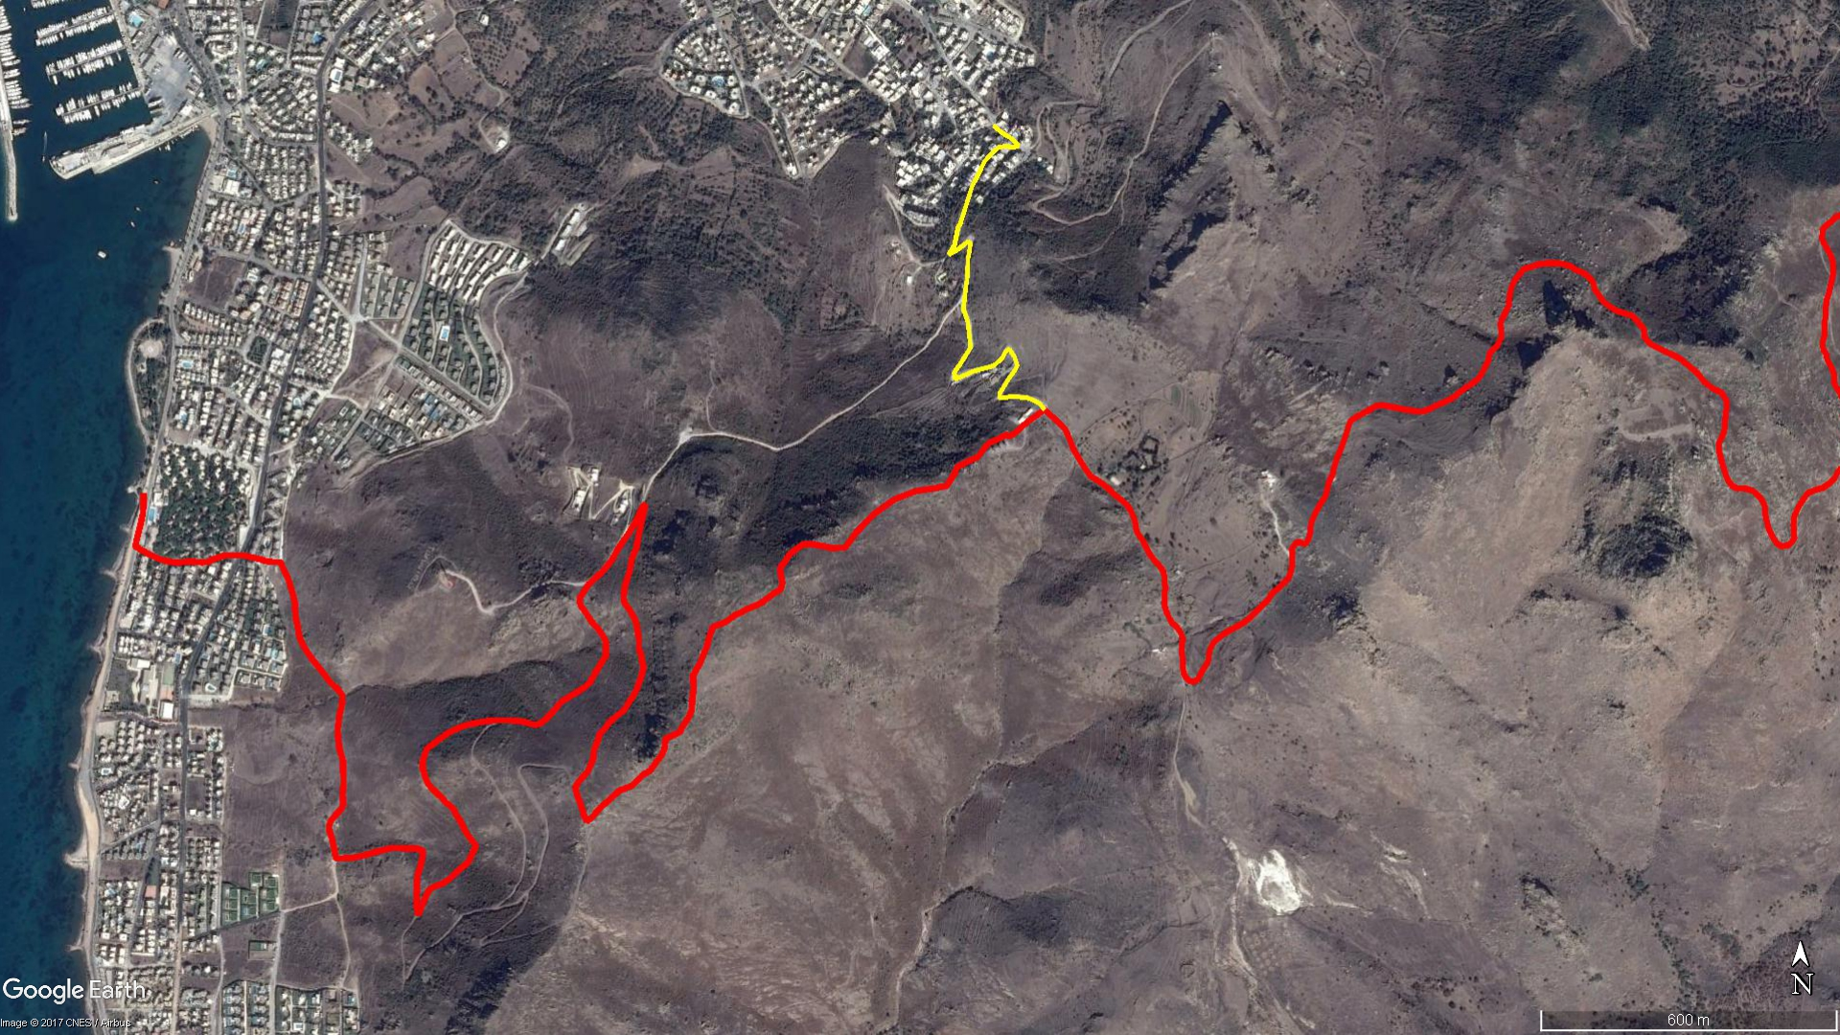

**Doğru Dağı**

**Kızılcamandıra**

**Bayrak Tepe**

**Sabancı Parkı**

**BOY KESİT**

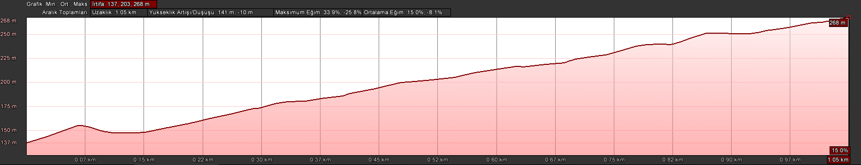

**Yel Değirmenleri**

**Karabağ**

**KOORDİNATLAR**

|  |  |  |
| --- | --- | --- |
| S.NU | ENLEM | BOYLAM |
| 1 | 36.999885995 | 27.277444590 |
| 2 | 36.999746546 | 27.277639024 |
| 3 | 36.999648173 | 27.277846396 |
| 4 | 36.999503654 | 27.278019471 |
| 5 | 36.999474197 | 27.277882849 |
| 6 | 36.999502928 | 27.277721799 |
| 7 | 36.999475809 | 27.277563494 |
| 8 | 36.999376720 | 27.277421339 |
| 9 | 36.999226469 | 27.277248701 |
| 10 | 36.998997940 | 27.277113881 |
| 11 | 36.998761592 | 27.276961175 |
| 12 | 36.998398291 | 27.276819145 |
| 13 | 36.998059952 | 27.276690230 |
| 14 | 36.998048691 | 27.276663499 |
| 15 | 36.998011172 | 27.276642140 |
| 16 | 36.997700713 | 27.276564464 |
| 17 | 36.997519577 | 27.276431829 |
| 18 | 36.997611996 | 27.276637276 |
| 19 | 36.997753432 | 27.276866121 |
| 20 | 36.997726630 | 27.276927272 |
| 21 | 36.997478304 | 27.276879455 |
| 22 | 36.997471189 | 27.276878324 |
| 23 | 36.997454178 | 27.276869770 |
| 24 | 36.997101627 | 27.276851967 |
| 25 | 36.996791609 | 27.276799373 |
| 26 | 36.996517134 | 27.276770431 |
| 27 | 36.996311330 | 27.276860428 |
| 28 | 36.996008887 | 27.276903468 |
| 29 | 36.995832082 | 27.276925400 |
| 30 | 36.995562525 | 27.276717800 |
| 31 | 36.995381459 | 27.276559130 |
| 32 | 36.995257919 | 27.276573151 |
| 33 | 36.995314861 | 27.276756912 |
| 34 | 36.995394475 | 27.276968938 |
| 35 | 36.995438264 | 27.277167357 |
| 36 | 36.995481286 | 27.277381166 |
| 37 | 36.995525890 | 27.277487838 |
| 38 | 36.995636736 | 27.277640771 |
| 39 | 36.995757711 | 27.277715774 |
| 40 | 36.995793804 | 27.277800869 |
| 41 | 36.995667811 | 27.277912842 |
| 42 | 36.995496895 | 27.277982117 |
| 43 | 36.995394775 | 27.277909284 |
| 44 | 36.995259340 | 27.277786194 |
| 45 | 36.995120540 | 27.277680748 |
| 46 | 36.994991962 | 27.277579077 |
| 47 | 36.994913083 | 27.277585100 |
| 48 | 36.994924580 | 27.277720044 |
| 49 | 36.994940415 | 27.277877105 |
| 50 | 36.994928716 | 27.278044112 |
| 51 | 36.994916518 | 27.278197889 |
| 52 | 36.994864595 | 27.278366313 |
| 53 | 36.994811704 | 27.278486884 |
| 54 | 36.994692539 | 27.278600897 |